http://www.gurufocus.com/financials.php?symbol=AXE
To perform bond pricing on any given date between , I need to know:
- Market value of firm assets on that date (as estimated via MLE)
- Market value of debt, (proxied by book value of total liabilities as per Li&Wong page 772 and Eom et al)
- Coupon rate, issue date and maturity date, coupon dates.
- Interest rate dynamics under the Vasicek model for that date, as estimated by examining the term structure on that date. We have access to the US interest rate data only from 19/03/1997 onwards; hence this dictates our lower date range for the bond sample because of our need for interest rate parameters to estimate bond prices.
- Default boundary (point at which bankruptcy proceedings commence). Depending on the model, this might be some ratio of total liabilities, or a constant value etc.
- Daily share price observations (given as adjusted closes). Question remains how to calculate the daily market value of equity accurately … My current method involves taking adjusted closing prices * shares outstanding for the year being tested, but this will be incorrect I think because the true market value at any point in time is the actual close price * number of shares at that time... Proposal: To use the adjusted close share prices for the period being examined, and multiply by the most recent # shares on issue value, since this should accurately reflect the total value of equity through time? MUST TEST THIS IDEA DALE – Jamie to comment?

Steps of the bond pricing process for any given date (it would ideally be desirable to price initial issues):
- Select all bonds (of all types) available for all USA firms (issued on a US stock exchange and in US dollars).
- Tally all bonds and locate firms that previously had no bond on issue and then at some point in the range between 1998 and 2007 issued a straight, non-callable, non-convertible bullet bond – i.e. Find firms that issued their first bond within the target date range, to most closely match the assumptions of the models.
- For any such firm that we find, estimate their asset dynamics for the calendar year before the issue date – see Duan’s paper on MLE for the inspiration for this technique, and his quote “equity holders treat yearly balance sheet statements as the chance to close the business if it encounters financial difficulties” for the inspiration for this ‘yearly psuedo-maturity of equity as a call option’ approach when estimating dynamics of underlying parameters.
- To estimate the asset dynamics (mu, sigma) of the firm using MLE, we consider equity to be some type of call option (depending on which bond model is being tested, straight BS, down-and-out, etc) on the market value of assets of the company. We retrieve:
  - The market value of the firm’s debt before they issue their bond (i.e. “Total Liabilities” as reported in the balance sheet at end of the year before the bond was issued). Thus, we proxy the market value of debt with the book value of total liabilities, since equity is worthless until all liabilities are paid off under strict priority rules.
  - The daily adjusted close share prices for the firm over that calendar year before the bond issue/pricing.
  - Interest rates dynamics for each day of that year.
- Once we have MLE estimates of mu and sigma for a given firm, use these to calculate the MLE-implied asset value of the firm, again based on the idea that equity is a call option on firm assets. Note: it would appear that the MLE approach is giving me reasonable estimates of asset dynamics parameters, but that the implied asset value is considerably different to the ‘Total assets’ listed in the balance sheets!!! Rechecked firm “Albemarle”, and the balance sheet doesn’t reflect the bond issue which occurred in 2005??!! Is this a problem with rubbish data again?? Switched to Anixter to continue demo as opposed to data I was using today.
Example of Anixter financials:
 | Dec-00 | Dec-01 | Dec-02 | Dec-03 | Dec-04 | Dec-05 | Dec-06
Cash | 20.8 | 27.2 | 19.1 | 101.4 | 53.4 | 21.8 | 50.9
Receivables | 419.4 | 265.5 | 257.8 | 312 | 620.4 | 772.3 | 1016.1
Bad Debt Reserve | 3.409 | 7.297 | 5.637 | 5.254 | 2.82 | 2.475 | 1.987
Inventory | 858.4 | 495.7 | 498.8 | 499.1 | 580.1 | 711.5 | 904.9
Total Current Assets | 1334.4 | 829 | 812.2 | 947.9 | 1281.9 | 1536.7 | 2020.3
PP&E | 56.5 | 55 | 59.1 | 43.1 | 42.6 | 53.1 | 62
Intangibles | 239.3 | 231.6 | 247.6 | 278.5 | 293.6 | 320.2 | 364.8
Deferred Charges | @CF | @CF | 0 | 0 | 0 | 0 | 0
Equity Investments | 0 | 0 | 0 | 0 | 0 | 0 | 0
Other Investments | 0 | 0 | 0 | 0 | 0 | 0 | 0
Total Assets | 1686 | 1198.8 | 1226 | 1371.4 | 1706.6 | 2012.1 | 2566.2
Debt - Current Portion | 0 | 0 | 0 | 0 | 0 | 0 | 212.3
Notes Payable | 0 | 0 | 0 | 0 | 0 | 0 | 0
Accounts Payable | 499.1 | 251 | 257.3 | 304.4 | 323.2 | 436 | 506.8
Taxes Payable | 8.1 | 4.4 | 4.7 | 1.2 | 32.8 | 27 | @CF
Total Current Liabilities | 646.8 | 352.7 | 349.7 | 385.2 | 466.6 | 604.1 | 922.5
Total Long Term Debt | 451.9 | 241.1 | 195.1 | 239.2 | 412.4 | 625.1 | 597
Deferred LT Taxes | @CF | @CF | @CF | @CF | @CF | @CF | @CF
Minority Interests | @CF | @CF | @CF | @CF | @CF | @CF | @CF
Total Liabilities | 1131.1 | 635.7 | 591.2 | 680.6 | 943.6 | 1305.7 | 1604.2
Preferred Stock - Total | 0 | 0 | 0 | 0 | 0 | 0 | 0
Common Equity | 554.9 | 563.1 | 634.8 | 690.8 | 763 | 706.4 | 962
Total Stockholders' Equity | 554.9 | 563.1 | 634.8 | 690.8 | 763 | 706.4 | 962
Common Shares O/S | 37.655 | 36.917 | 37.501 | 36.376 | 37.376 | 38.378 | 39.501

Example of Anixter bond information:
BondDSCode | AOS | C | CD | ID | RD | FSET
48998L | 200000 | 5.95 | 1020108 | 24/02/2005 | 1/03/2015 | 1/03/2015

Notice: For Albemarle the bond is issued in 2005, but we see long term debt shoot up massively in 2004, and it actually decreases in 2005?? How can this be possible, unless the data is rubbish? Hence why I switched to Anixter for this demo, see if it behaves any better...
So, in order to price the bond issue in 2005, I take the equity prices observed in 2004 calendar year, and overlay the book value of debt from the end of calendar year 2003:
Graph of Anixter share prices (to see drift and volatility – X axis = 1 year):
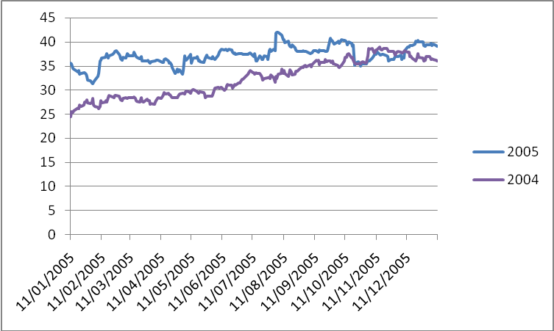
Including the debt proxied by book value of total liabilities:
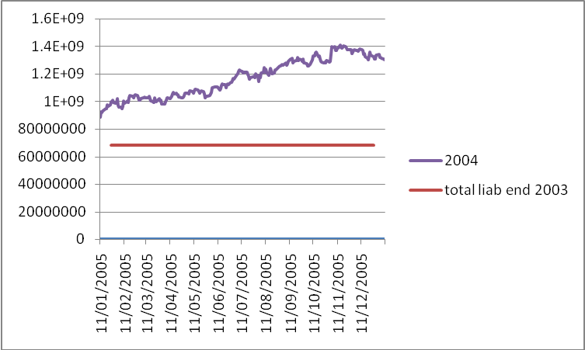

Remembering that the bond is issued at the start of 2005, and based on the book value of total liabilities which will appear current through 2004, we now perform MLE of asset dynamics for 2004:
Example of parameters estimates by MLE and “equity as a call” technique:
Estimate dynamics of assets for: Anixter
Estimating asset dynamics parameters for the year: 2004
Calculated MLE of asset params-> mu:0.21763, sigma: 0.15689

Graph of Anixter 2005 share prices, book value of total liabs at end of 2004 and implied asset value (ignore slight scaling shrinkage of the X-axis asset value entries- is related to excel entry) based on the asset dynamics estimated for the 2004 calendar year:
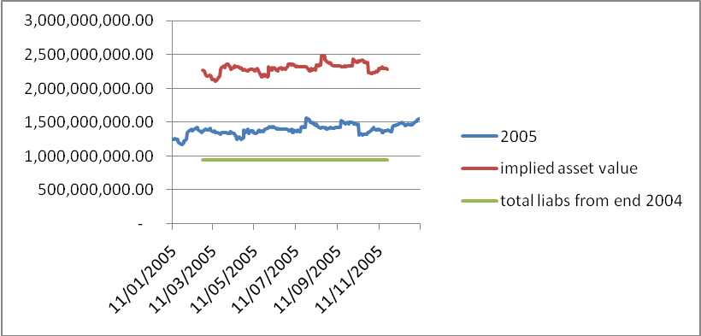
So... the MLE method results in an estimate of asset values of around 2,250 million for the 2005 calendar year, whereas the financial statement of balance sheet at end of 2005 states it to be around 2,012 million....
Now, we have the asset value prediction for any day of the year in 2005, and now we turn our attention to pricing a bond issued on the 24th of Feb 2005. Recall that prior to this issue date, there are no bonds in the total liabilities.
For the Merton bond pricing model, we need V the value of the company assets on the 28th (2.36 billion) (this is the first day we have a bond price observation for after bond issued on the 24th!), which we take from our implied values plot above. We take X the book value of total liabilities from end of year 2004, which is 934 million, and for sake of argument say that the firm begins bankruptcy proceedings whenever the assets value wanders below that total liability value, that is boundary H = X .
Set recovery rate of face value of bond to be 50%, coupons are lost entirely in event of default, interest rate dynamics are retrieved from Vasicek term structure as at 28th of Feb, and we feed all these values into our bond pricing model to evaluate the price of the bond.

As at 28th Feb, the price predicted using these values as input parameters:
r0 = 0.04, c = 5.95%, rr_fv = 0.5, rr_c = 0, sigma = 0.15, mu = 0.21, V = 2.34b, X=0.9b
predictedBondPrice = 1.06073960150472 (*100)
actual bond price (on the 28th): 100.7558
taking a later observation date, 6 months down the track (22nd Aug):
predictedBondPrice = 1.10349116979946
actual price: 98.6374
These values are producing “default probabilities” of effectively zero, the company is considered super-safe by the model and has basically no chance of default… so the debt is very expensive.
Am thinking that somehow, I need to adjust either the V or the X or probably both, to account for the “new” total value of total liabilities + the new debt issue.
That is, am thinking that to use the previous year total liability as the default boundary ignores the fact that the company will have greater total liabilities after the bond issue, so suggest the default boundary H should actually equal [X_2004 + FV_bond] since that is what the total liabilities will actually equal AFTER the bond has been issued...
But... that also means that technically speaking, the asset value of the company increases as well by FV_bond presumably... but the RATIO of [Assets/Liabs] will change.
For example, imagine BEFORE bond issued, V=1, X=0.7, therefore V/X = 1.42. But if I then issue a bond with face value= 0.1, after the issue, V_i = 1.1, X_i = 0.8, and V/X = 1.37, thus representing the fact that the company is now more risky than before....

Questions:

- Why do we say V = D + E, when it seems that the formula should be V = E + L??
- Should I be pricing equity based on current amount of shares on issue if i am using adjusted closing prices, instead of current method of using adjusted close prices and historic # of shares on issue?

Additional Information:
Full parameter estimates for Anixter:
Estimate dynamics of assets for: Anixter
Estimating asset dynamics parameters for the year: 2004
Calculated MLE of asset params-> mu:0.21763, sigma: 0.15689
Calculated implied assets values with MLE parameters.
Estimating asset dynamics parameters for the year: 2005
Calculated MLE of asset params-> mu:0.055506, sigma: 0.18009
Calculated implied assets values with MLE parameters.
Estimating asset dynamics parameters for the year: 2006
Calculated MLE of asset params-> mu:0.17515, sigma: 0.20477
Calculated implied assets values with MLE parameters.
Estimating asset dynamics parameters for the year: 2007
Calculated MLE of asset params-> mu:0.12464, sigma: 0.22804
Calculated implied assets values with MLE parameters.
Total time to estimate parameters for Anixter: 278.0066

Graphs of Anixter share prices by year:
